Internal complaints procedure
for students and parents/legal guardians

Vardafjell vgs is committed to providing support and service to all its students. Feedback is highly valued, and it is a major contributor to our ability to grow, develop and change with our students’ needs. Therefore, we value the views and inputs from students and
parent/guardians to meet our mission of providing a safe and high-quality learning space.

We encourage all stakeholders to bring forward questions and concerns early, so we might be able to address them before they become complaints.

Principles
The principles of our concerns and complaints procedure are to ensure that there is effective communication across all stakeholders to facilitate the best resolution for all involved. We understand that the school is an educational institution as well as a workplace, and that everyone must have conditions to thrive and grow. We aim to have a fair process that opens lines of communication for the timeliest resolution. The process must be based on mutual respect, trust, and openness.

Who can file concerns or complaints?
Students can file concerns or complaints at any time. If the student is below 18 years, the school is obliged to involve the legal guardians. Legal guardians can file concerns or complaints freely until the student is 18 years of age. Once a student has turned 18, the student must provide their written consent for parents/guardians to file concerns or
complaints on the student’s behalf.

Who is responsible for handling the complaint?
The first person contacted in the complaint process is responsible for ensuring that a line of communication is established, and the relevant people are included in the dialogue needed to address the grievance early on. The final stage of the complaint process is the responsibility of the Head of School.

Cases involving the Education Act §12, and the Working Environment Act
stipulate formal procedures and the Head of School is responsible for ensuring that these requirements are followed. The Head of School is also responsible for ensuring that the School’s Routines and Rules, as well as any other laws, agreements and policies, are followed.

Procedures for various concerns
All concerns or complaints should start as close to the root of the issue as possible and be reported as soon as possible.

Complaints can be based on one or both of the following:
- Academic concerns
- Social and emotional concerns

Academic concerns
Complaints about academic issues involve teaching practices, teacher feedback, assessment, classroom management, teacher absence, and quality of teaching resources. In line with the close to the root principle, a complaint should follow this line of communication:
Subject teacher – personal tutor – DP coordinator – Head of School

The school follows the guidelines from the IB when it comes to Enquiry upon results in relation to the exam results. The student must contact the IB coordinator if they want to file an enquiry upon results.

Socio-emotional concerns
Complaints about socio-emotional issues involve offensive behaviour in the form of discrimination, harassment, exclusion, bullying (by employees or students) or violence. The line of communication for complaints about socio-emotional issues may vary according to the issue of the complaint and the student’s relationship to the employee, but the line may be as follows:
Subject teacher or Personal Tutor – Nurse or Counsellor – DP Coordinator – Head of School

Complaints about academic or socio-emotional issues | Follow-up
Examples:  - The employee does not fulfil their professional duties, so that the student’s rights as described under the Education Act and/or IBO requirements are violated.  - Complaints may also address any failure by school managers to follow up on an employee’s breach of the Education Act and/or IBO requirements. | In a complaint against an employee or a manager:  - The student/guardian should first address their complaint to the employee. It should be as concrete as possible. The student or student group can have the assistance of their Class Representative and/or Personal Tutor when a complaint is made orally.  - If the student(s) find it difficult to convey a complaint to an employee directly, it can be communicated via the employee’s immediate manager (Head of Department).  - On the receipt of a complaint, the school must follow the action plan as outlined by Rogaland County.

Alternative line of communication for complaints about socio-emotional concerns
The Head of Department visits all classes every year in August/September to inform the students about the Education Act §12, and of the importance of talking to an adult if they experience bullying. Reporting is particularly important if it is an adult who bullies. The school encourages personal reports and conversations about the case, but if this is difficult for the student, it is also possible to file a complaint via our homepage:
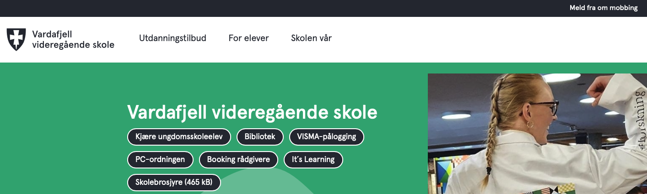

Clicking the link will lead you to this page:
https://www.rogfk.no/vare-tjenester/skole-og-utdanning/opplaring-i-skole/skolemiljo/rett-til-trygt-skolemiljo/

Routines, your rights and action plans
The school follows the internal guidelines of Rogaland County, with detailed templates to action plans for all parties and various cases. For further information: https://www.rogfk.no/vare-tjenester/skole-og-utdanning/opplaring-i-skole/skolemiljo/rett-til-trygt-skolemiljo/

Formal complaints towards the IB
Before filing a formal complaint with the IB, contact the DP coordinators for support and
advice moving forward.

If it has not been possible to resolve your concerns or complaints informally, a formal
complaint can be issued. The following document outlines the formal complaint procedure: https://www.ibo.org/contact-the-ib/feedback-and-complaints/

Written by: Gro Torill S. Nypan, IBDP Coordinator, in collaboration with Head of School and employees.
Date: 13 December 2024
Last reviewed:
Reviewed by:

