Assessment Policy

The IB Diploma Programme is a challenging, broad and balanced two-year programme of international education for students aged 16 to 19. The programme is designed to equip students with the basic academic skills needed for university study, further education and their chosen profession, as well as developing the values and life-skills needed to live a fulfilled and purposeful life.

Philosophy of assessment
Vardafjell Upper Secondary School strives to make sure that all assessment identifies what students know, understand and can do. Information gathered through student assessments is used to continuously evaluate student learning to develop planning, teaching and learning. All assessment is used to meet the school’s goal of helping each student achieve their full academic potential.

The purpose of this Assessment Policy is to contribute to a common understanding of expectations and practices of assessments at Vardafjell Upper Secondary School for all stakeholders, including students, guardians and teachers in the IB Diploma Programme (IBDP).

All assessments are in coherence with the principles described by the IBO in Diploma Programme Assessment procedures (IBO, 2025) and Assessment Principles and practices – Quality assessments in a digital age (IBO, 2019).

Assessment of students’ work
All assessment is criterion-based and not norm-referencing (scores are not related to the normal distribution). Assessment should always reflect a student’s level of competence against the expected standards for each subject as described by the IBO. Both national (https://www.udir.no/in-english/) and IBDP assessment philosophies are taken into consideration when assessing students work. The term grades and the predicted grade in each subject set by the IB teachers will always be based on several different elements. The final summative grades are always given by the IBO based on IA grades and the final exams in the different subjects. For more information on specific assessment criteria, see the current subject guides for each individual IB subject on the schools learning platform (Teams). All subject teachers will inform the students thoroughly about the expected standards for the individual subject assessment components.

The IBO has listed a set of IB approaches to learning skills. The five learning skills are: thinking skills, communication skills, social skills, self-management skills and research skills. All assessments should be influenced by the five learning skills both when deciding what should be assessed and how it should be assessed. This is an integrated part of the school’s continuous focus on approaches to teaching and learning (ATL).

Formative assessment
Formative assessment (assessment for learning) represents the process of gathering, analysing, interpreting and using the evidence to improve student learning and to help students to achieve their potential (Guidelines for developing a school assessment policy in the Diploma Programme, 2010). All teachers at Vardafjell Upper Secondary School work towards providing descriptive and timely feedback on all formative assessment throughout the school years leading up to the final exams. The focus is always on monitoring progress, describing to the students the areas that need improvement and motivating students for new progress. Self-assessment and student-subject teacher conferences are used to help the students become familiar with the assessment criteria, how the work is evaluated and how they can use the five approaches to learning skills to fully achieve their potential. The school uses the IB assessment criteria and descriptors found in the subjects guides to determine achievement levels.

Formative assessments are scheduled regularly throughout the two school years in all IBDP subjects. The dates will be clearly communicated to the students in the school calendars and on the subjects-specific pages on the school’s learning platform (Teams) to help students with time-management. On average each subject will have at least two-three formative assessments during the four semesters of the IBDP. The term grades are recorded in Visma InSchool (VIS – a digital platform for time schedules, and for recording and reporting assessments and student absence). Parents/legal guardians for students under 18 may also request access to VIS. The students and guardians (of students under 18) will also get a written summary of engagement and a term grade for each subject in December and June of year 1 (IBDP1) and in December of year 2 (IBDP2).

Summative assessment
Summative assessment (assessment of learning) is concerned with measuring student performance against Diploma Programme assessment criteria to judge levels of attainment (Guidelines for developing a school assessment policy in the Diploma Programme, 2010). In the IBDP, the internal assessments (IAs) as well as the final exams will show the summative assessment of learning. The final grades are issued on the 6th of July each year for May exams. The IBDP coordinator is available for the students in the days after the exams to give guidance on any questions they might have after the issue of results, including enquiry upon results (EURs).

The IB uses both external and internal assessment in the summative assessment in the DP.

External assessment:
Examinations form the basis of the assessment for most courses. This is because of their high levels of objectivity and reliability. They include (depending on subject):
- essays
- structured problems
- short-response questions
- data-response questions
- text-response questions
- case-study questions
- multiple-choice questions

Internal assessment (IAs)
Teacher assessment is also used for most courses. This includes:
- oral work in languages
- laboratory work/fieldwork in the sciences
- exploration in mathematics
- historical investigation in history
- a report on an experimental study in psychology
All exams will be organized by the IBDP coordinator as described in the IBO in Diploma Programme Assessment procedures (2025) and the annually updated Conduct of examinations booklet.
For more information on the details of assessment, please refer to the IBDP subject guides and the IB assessment principles and pratices guides available from the IBO website: https://www.ibo.org/programmes/diploma-programme/assessment-and-exams/

For more information on requirements for the award of an IBDP diploma, please refer to Appendix A: A2.2 Award of the Diploma from Diploma Programme Assessment procedures (2025). A copy of this is to be found on Teams (VA-IB students, in the document called Award of Diploma and Generell studiekompetanse). Information about the Norwegian “Generell studiekompetanse” is to be found in the same document (rules from The Norwegian Universities and Colleges Admission Service)

Attendance regulations and assessment
According to the Norwegian National Curriculum (NNC) standards a student’s undocumented absence in any subject must not exceed 10% (for more info go to the web page of the Norwegian Directorate for Education and Training: https://www.udir.no/regelverk-og-tilsyn/skole-og-opplaring/rundskriv-om-fravarsgrensen/ and https://www.udir.no/regelverkstolkninger/opplaring/forskrift-om-grunnskoleopplaringa-og-den-vidaregaande-opplaringa-opplaringsforskrifta/tredje-delen--fellesreglar-for-grunnskoleopplaringa-og-den-vidaregaande-opplaringa-for-barn-og-unge/kapittel-9-individuell-vurdering/i.-generelle-reglar/-9-8-fravarsgrense-i-vidaregaande-skole/.

If the 10% limit is exceeded in one subject, the student will not receive a term grade for terms 1,2 (IBDP1) and 3 (IBDP2) and/or not get a predicted grade for term 4 (IBDP2) in the subject(s) in question. If no predicted grade is reported to the IB at the end of term 4, no grade will be awarded in the subject(s) and hence no Diploma will be issued. If the undocumented subject absence is more than 10%, but less than 15%, the Head of School can grant, under special circumstances, an exception to the absence rule.

Assessment deadlines
Vardafjell Upper Secondary School, represented by the IBDP coordinator and the subject teachers, set all the internal deadlines for assessment. All subject teachers work together, both horizontally, vertically and subject specific, to ensure that the student workload is spread out throughout the two years of the IBDP. This is clearly communicated to the students in the IBDP1 and IBDP2 assessment calendars (on Teams), and also communicated using the subject specific pages on the school’s digital learning platform (Teams). All IBDP students are expected to keep all deadlines, by working continuously on their self-management skills. In cases where adverse circumstances may prevent submission on deadline, the subject teacher and personal tutor must be contacted immediately and before the pass of the deadline. The teachers will then discuss the matter with the IBDP coordinator, who decides if an extension to the deadline will be granted. If a student misses an internal deadline for any part of an official IBDP assessment, the school is under no obligation by the IBO to allow the student to turn in the assessment late, even if the IBO’s deadline is several months away.

Assessment and inclusion
Students with special education needs are defined as those who have the intellectual capacity to meet all curriculum requirements, but who have individual learning needs and who require special arrangements to demonstrate their level of achievement. Where standard assessment conditions, for both formative and summative assessments, could put candidates with special educational needs at a disadvantage by preventing them from demonstrating their level of attainment, special arrangements may be authorized by the IB. Inclusive access arrangements will be considered for students with learning difficulties, alongside students affected by temporary, long-term or permanent disability or illness. For more details, please refer to the school’s Inclusion Policy.

Responsibilities linked to assessment
“Schools are responsible for ensuring that candidates comply with all assessment requirements for the DP. If candidates do not comply with these requirements, then no grade will be awarded in the subject(s) or requirement(s) concerned” (Rules for the IB World Schools, October 2024, article 5.22).

IBDP coordinator responsibilities
- storing the exam papers in the school’s safe and submitting them as soon as possible to the IBO after the completion of each component
- ensure that both students and teachers keep up all deadlines; both internal and external ones
- double check that all the students’ forms, IA components and the EE is submitted to the IBO through ibis
- arranging all of the IBDP Exams in accordance with the current IBO examination rules, including invigilator training
- arranging a meeting annualy, where the assessment practices at Vardafjell Upper Secondary School is evaluated and thereafter to update the assessment policy accordingly
- provide access for the student to IBIS, and ensure that they know how to proceed when uploading their coursework.
- make an assessement year plan for IBDP1 and IBDP2 in collaboration with all involved subject teachers
- all procedures for access arrangements. Please refer to the school’s Inclusion Policy for details

IBDP subject teacher responsibilities
- understanding the nature of the assessment system to which they are submitting their students
- use and design several assessment instruments that encourage good education and constructive student involvement.
- checking that their own marking practices comply with the IBDP marking standards by analyzing examples of former work which has been marked, attending regular IBDP professional workshops and by reading subject reports after each exam session
- read all guidelines and support material available on My IB
- dicuss with a collegue some internally marked courseworks to get an internal quality check
- ensure the authenticity of all student work throughout the IBDP by keeping a close eye on any sign of academic misconduct. Please refer to the Academic Honesty Policy for details.
- submit predicted grades, marks and upload any required material to IBIS for internal assessment on the work done by students for a subject and level.
- focus on and is aware that all internal deadlines are binding
- store exam components (oral exam recordings, IAs, EEs and so on) in their own files for at least one year
- ensure the uploading of the correct and authentic student work to IBIS.
- use ATL consciously to plan both their lessons/learning activities and in all their assessments

IBDP student responsibilities
- try to understand the assessment system against which they are assessed
- try to gain an understanding of the objectives and aims against which their achievements are evaluated and actively engage in peer assessment and self-assessment
- engage to gain an insight into the marking of different exam papers
- read and comply with the e-coursework guide in IBIS and upload all necessary components
- ensure the authenticity of all work thorughout the IBDP. Please refer to the Academic Integrity policy for details.
- focus on and be aware that all internal deadlines are binding
- notify the subject teacher and the personal tutor immediately, and before the deadline, if adverse circumstances may cause challenges in keeping any deadlines
- notify the personal tutor of any needs for inclusive arrangements as soon as possible after starting IBDP1 or if the need for inclusive arrangements changes over the two years as an IBDP student. Please refer to the Inclusion policy for details.

Documents used when writing the assessment policy
Guidelines for developing a school assessment policy in the Diploma Programme (IBO, 2010)
Rules for IB World Schools (IBO, 2024)
Diploma Programme Assessment procedures (IBO, 2025)
Assessment Principles and practices – Quality assessments in a digital age (IBO, 2019).

Revised November 2019
Revised January 2025
Next revision June 2025

Appendix A: Award of the IB diploma and “Generell studiekompetanse”
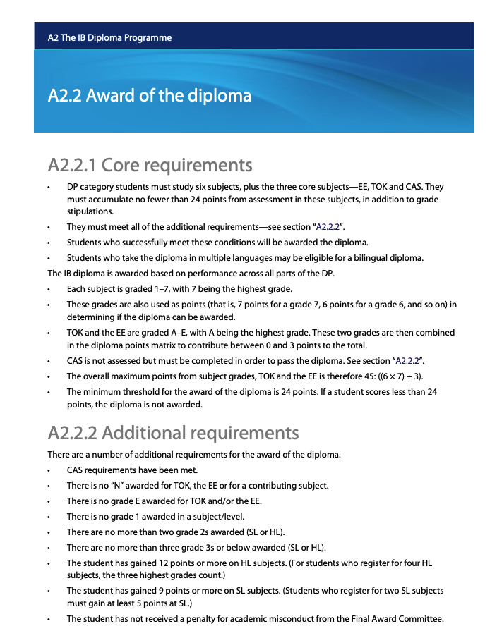

Generell studiekompetanse
If you are not awarded the IB Diploma, you can still get admission to education in Norway (generell studiekompetanse) if you fulfill the requirements from Samordna opptak.

By January 2025, the requirements are:
Diploma Programme Course Results (previously IB Certificate) with
- 3 standard level subjects and 3 higher level subjects
(alternatively 2 standard level subjects and 4 higher level sbjects) and
- at least 20 points, including any points for Theory of Knowledge and
Extended Essay and
- the grade 3 or better in all subjects and
- passed Theory of Knowledge and Extended Essay and
- Creativity, Action and Service (CAS) must be “fully satisfied”

Please find updated details here: https://www.samordnaopptak.no/info/utenlandsk_utdanning/ib/opptakskrav/

